# Software User Manual

## Installation Guide

### Server’s requirement

#### Hardware minimum requirement

* CPU Core 2 Duo 2.0GHz.
* 2GB RAM or more
* 250GB.

#### Software requirement

* Web Server: Internet Information System – IIS 7.0
* Microsoft Windows 7 or later
* SQL Server 2008 R2

### Deployment at server side

#### Prepare deployment package

Extract the deployment package to a folder on the server.

For example: *E:\deployment\OMCS*

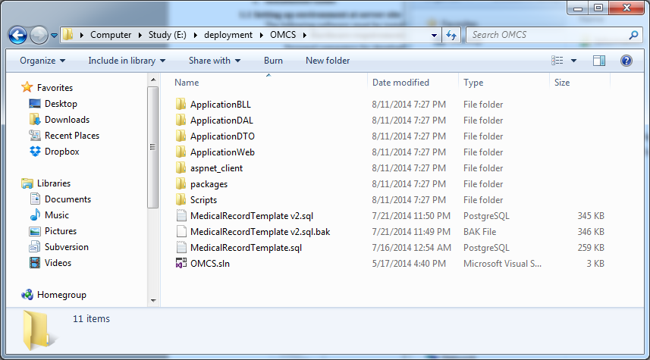

**Figure 1: Prepare deployment package**

#### Deploy database

##### Open Microsoft SQL Server Management Studio

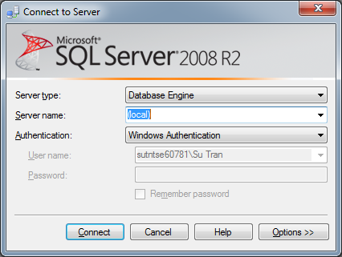

Figure 2 Microsoft SQL Server Management Studio

##### Find and execute sql file

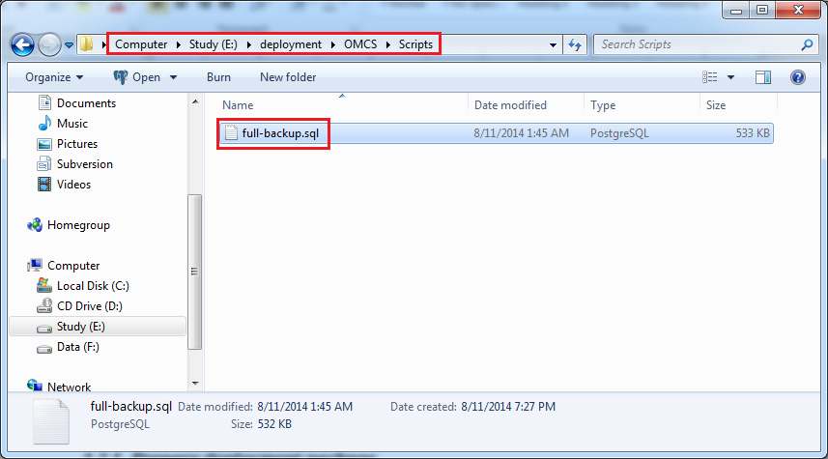

Figure 3 SQL - Full Backup

##### Configure connection string

##### Find and open *Web.config* in deployment folder with a text editor

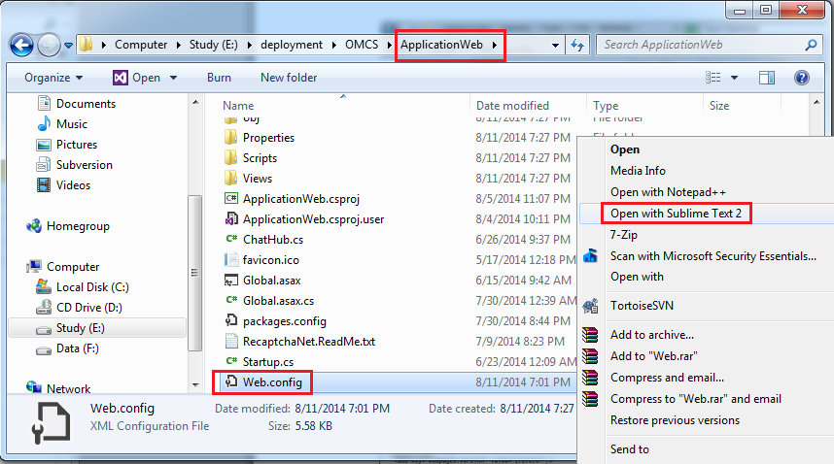

Figure 4 Connection String - 1

* Change selected text with the correct information to connect your *Microsoft SQL Server*

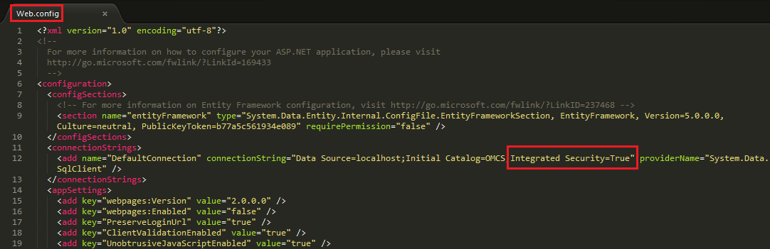

Figure 5 Connection String - 2

* For example, you can use your account like this

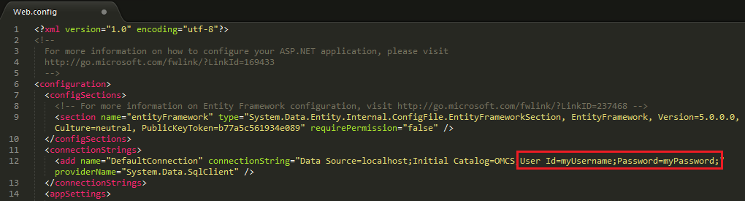

Figure 6 Connection String - 3

#### Prepare for deployment

* Open *“Internet information Services (IIS) Manager”*.
* Click *“Change .NET Framework Version”* and change to *v.4.0….*

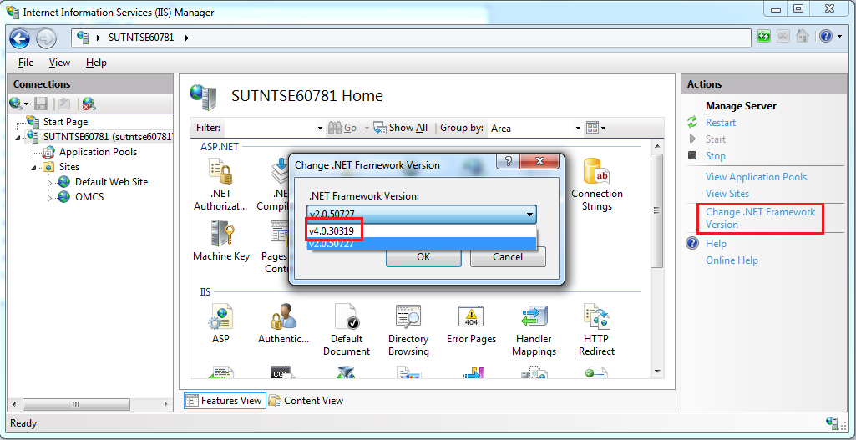

Figure 7 IIS Manager - 1

* Right click on *“Sites”* folder in left content, select *“Add Web Site”.*

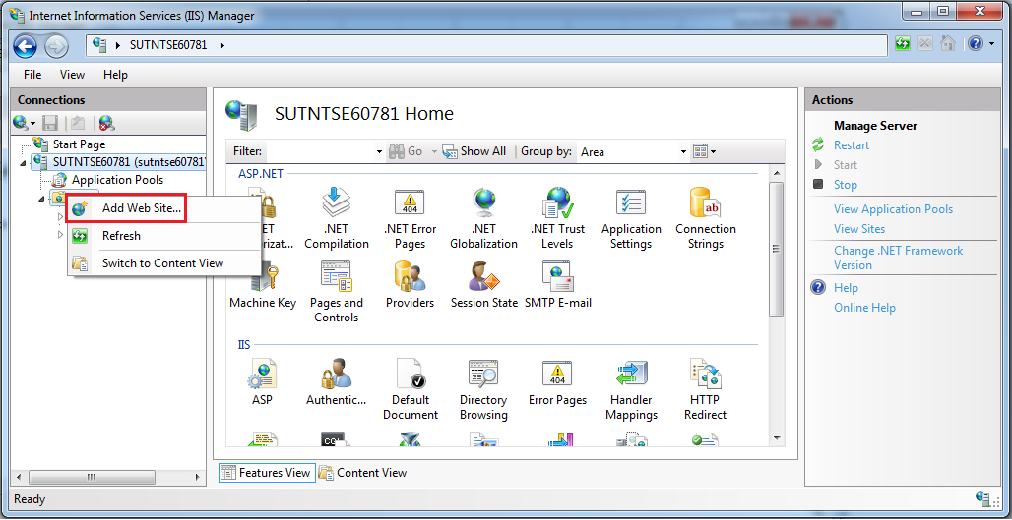

Figure 8 IIS Manager - 2

* Enter *“OMCS”* in the “*Site name*” text box.
* Click “…” button to browse to the place of the project source. In this case is “*E:\deployment\OMCS*”

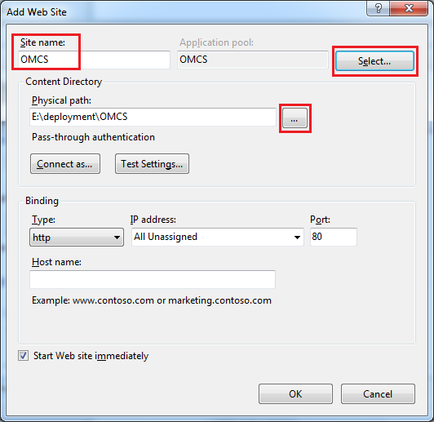

Figure 9 IIS Manager - 3

* Click “*Select*” button, another dialogue appears. You choose ASP.NET 4.0 in the list. Then click “*OK*” twice

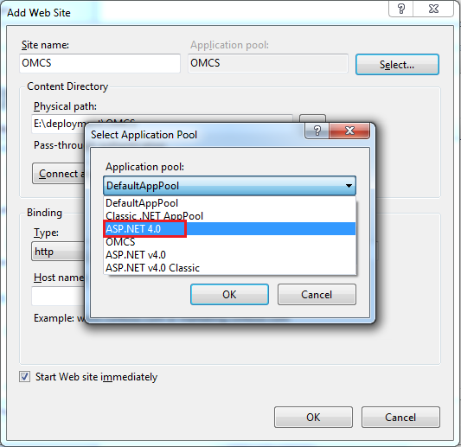

Figure 10 IIS Manager - 4

* Now, deployment is just finished. Open your favorite browser and enjoy using OMCS.

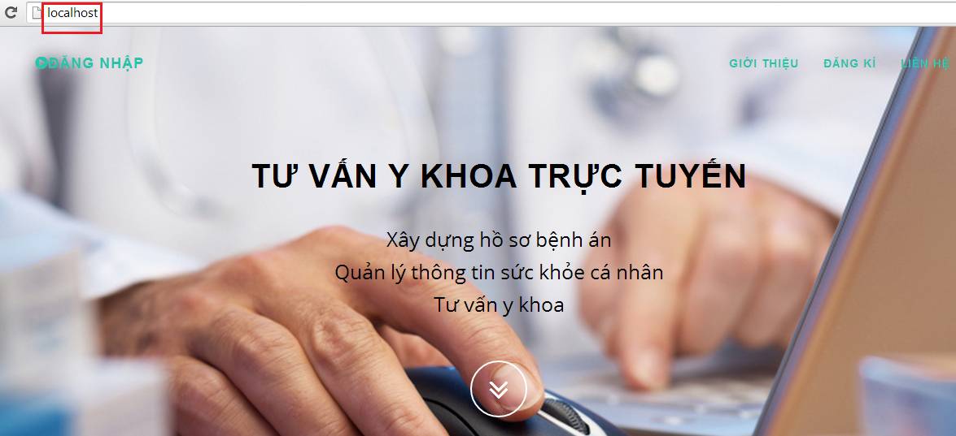

Figure 11 Deployment Successful

## User Guide

### Login

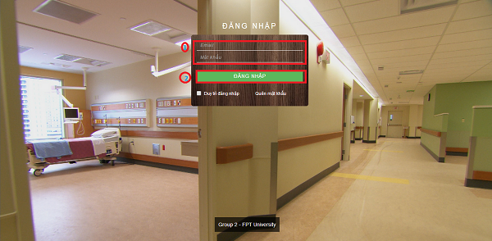

Figure 12 Login Page

|  |  |
| --- | --- |
| **Step** | **Description** |
| 1 | Fill Email and Password  (Sample admin account:  Email: admin@ymail.com  Password: 123456) |
| 2 | Click on “Đăng Nhập” button to login. |

Table 1 Login Step

### Patient – User Info

#### Change Profile Image

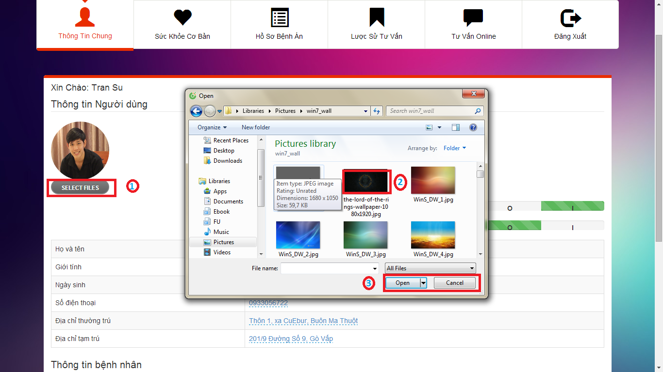

Figure 13 Change Profile Image Windows

|  |  |
| --- | --- |
| **Step** | **Description** |
| 1 | Click on “SELECT FILES” button to open windows explorer. |
| 2 | Choose image to upload. |
| 3 | Click on “Open” button to upload the image.  Click on “Cancel” button to close the windows |

Table 2 Change Profile Image Step

#### Edit Patient Info

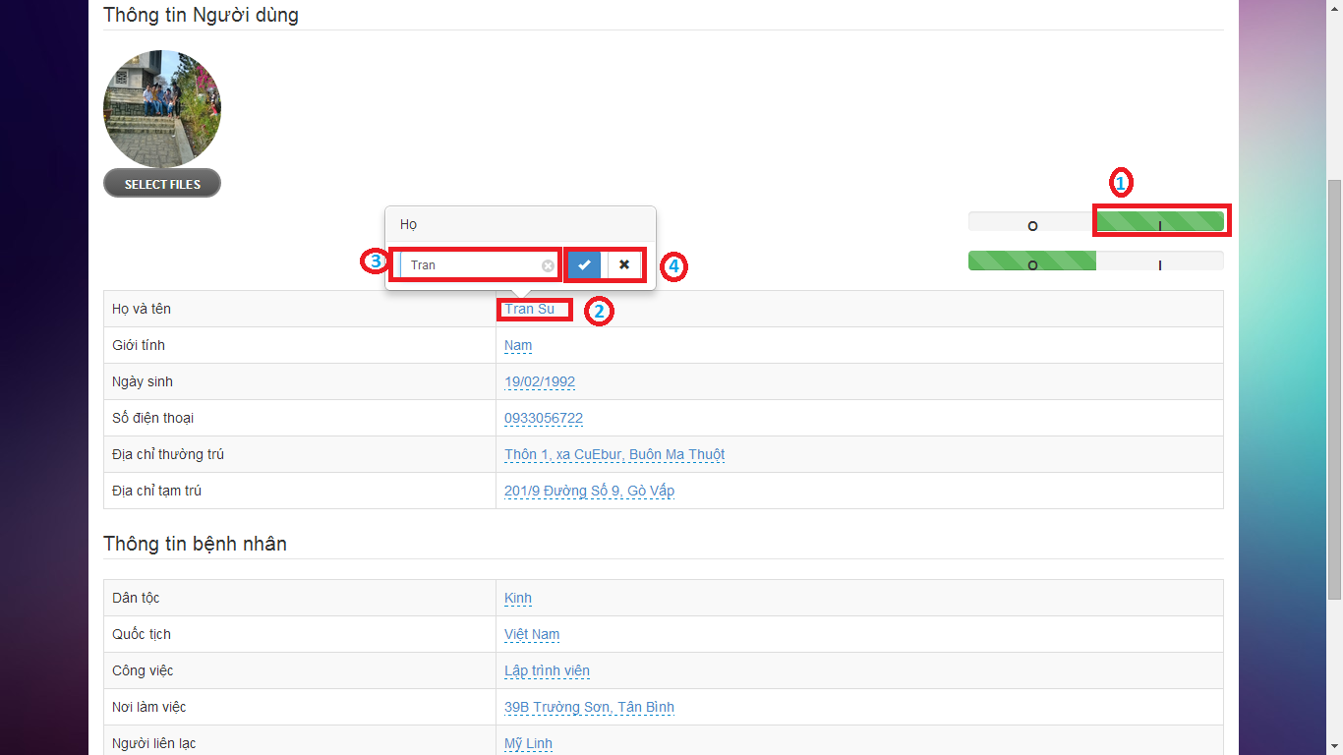

Figure 14 Edit Patient Info

|  |  |
| --- | --- |
| **Step** | **Description** |
| 1 | Click on “I” button to activate “Edit Patient Info” function. |
| 2 | Click on field that user wants to edit |
| 3 | Fill the text-box/select-box |
| 4 | Click on “✓” button to save the change.  Click on “×” button to cancel. |

Table 3 Edit Patient Info Step

### Patient – User Health Record

#### Edit Personal Health Record

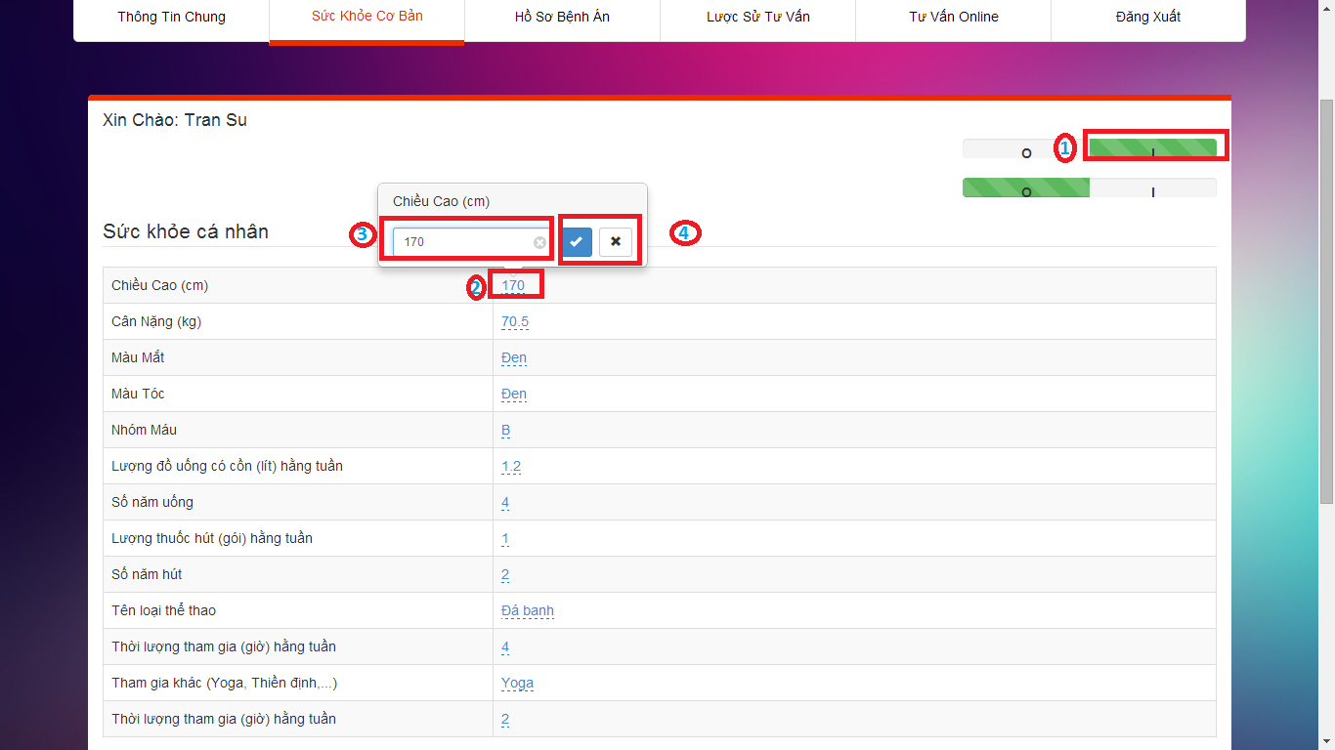

Figure 15 Edit Personal Health Record

|  |  |
| --- | --- |
| **Step** | **Description** |
| 1 | Click on “I” button to activate “Edit Personal Health Record” function. |
| 2 | Click on field that user wants to edit |
| 3 | Fill the text-box/select-box |
| 4 | Click on “✓” button to save the change.  Click on “×” button to cancel. |

Table 4 Edit Personal Health Record Step

#### View Patient Sample

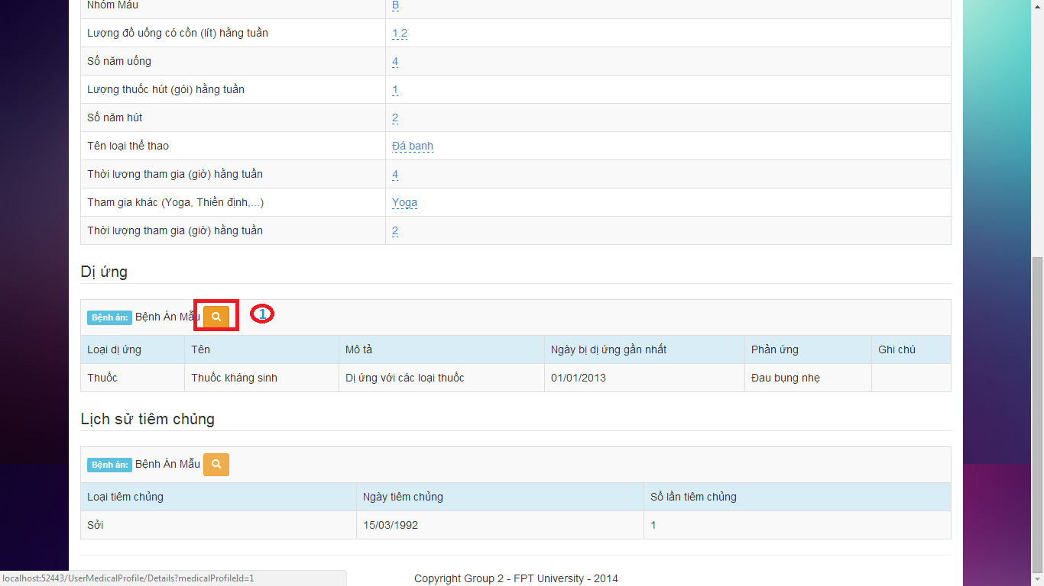

Figure 16 View Patient Sample

|  |  |
| --- | --- |
| **Step** | **Description** |
| 1 | Click on “Xem mẫu bệnh án” button to view the patient sample. |

Table 5 View Patient Sample Step

### Patient - View Medical Profile Sample

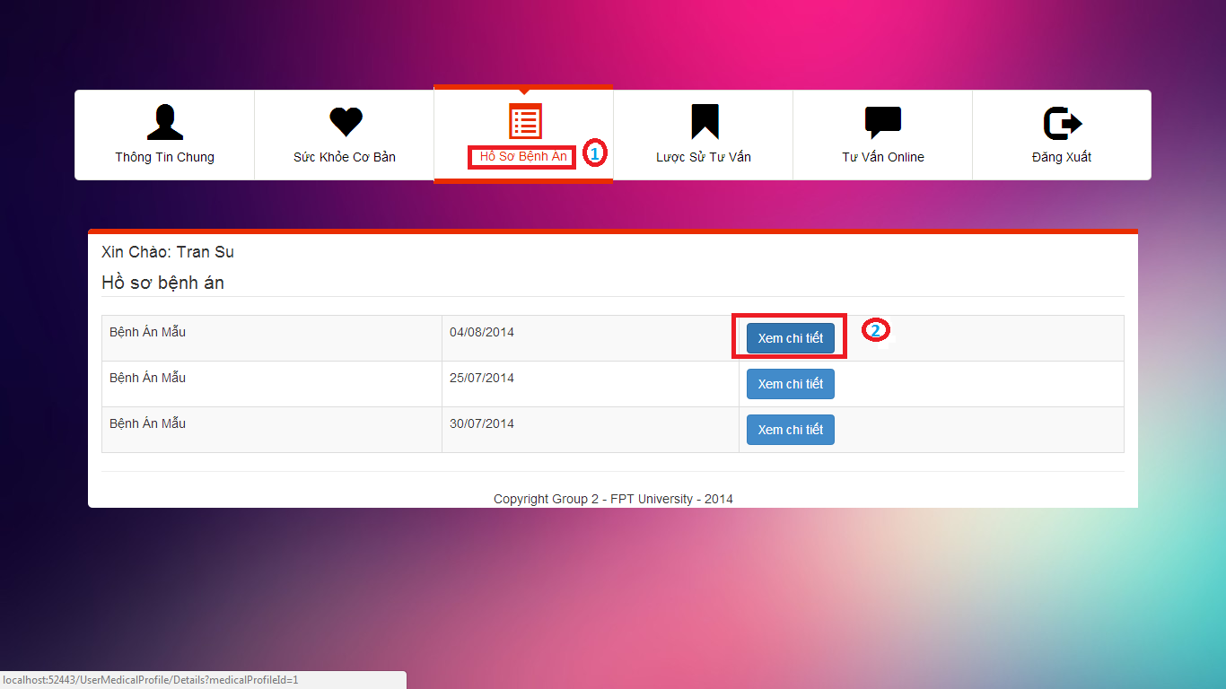

Figure 17 User Medical Profile Page

|  |  |
| --- | --- |
| **Step** | **Description** |
| 1 | Click on “Hồ sơ bệnh án” link to go to “Hồ sơ bệnh án” page. |
| 2 | Click on “Xem chi tiết” button on “Hồ sơ bệnh án” page. |

Table 6 View Medical Profile Sample Step

### Patient – View Consult History

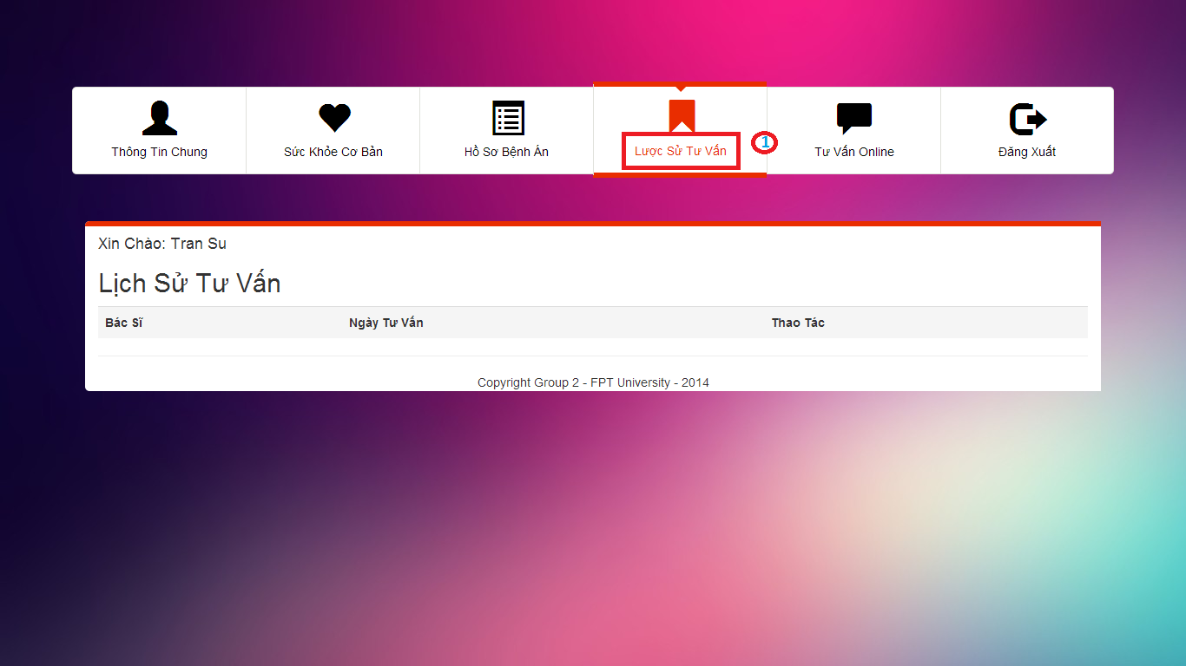

Figure 18 View Consult History Page

|  |  |
| --- | --- |
| **Step** | **Description** |
| 1 | Click on “Lược sử tư vấn” link to view the consult history. |

Table 7 View Consult History Step

### Patient – Consult Online

#### Chatting

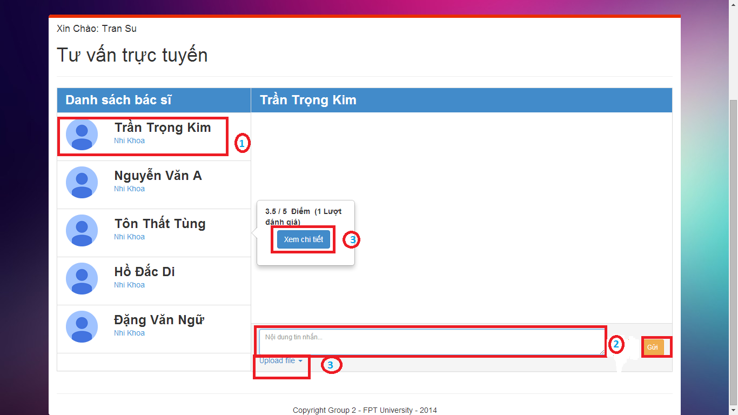

Figure 19 Consult Online Page – Chatting

|  |  |
| --- | --- |
| **Step** | **Description** |
| 1 | Click on “Doctor name” on doctor list to choose the doctor that patient wants to chat. |
| 2 | Fill the text-area. |
| 3 | Click on “Gửi” button to send the message.  Click on “Upload file” button to upload file.  Click on “Xem chi tiết” to view details of doctor |

Table 8 Chatting Step

#### View Doctor Details

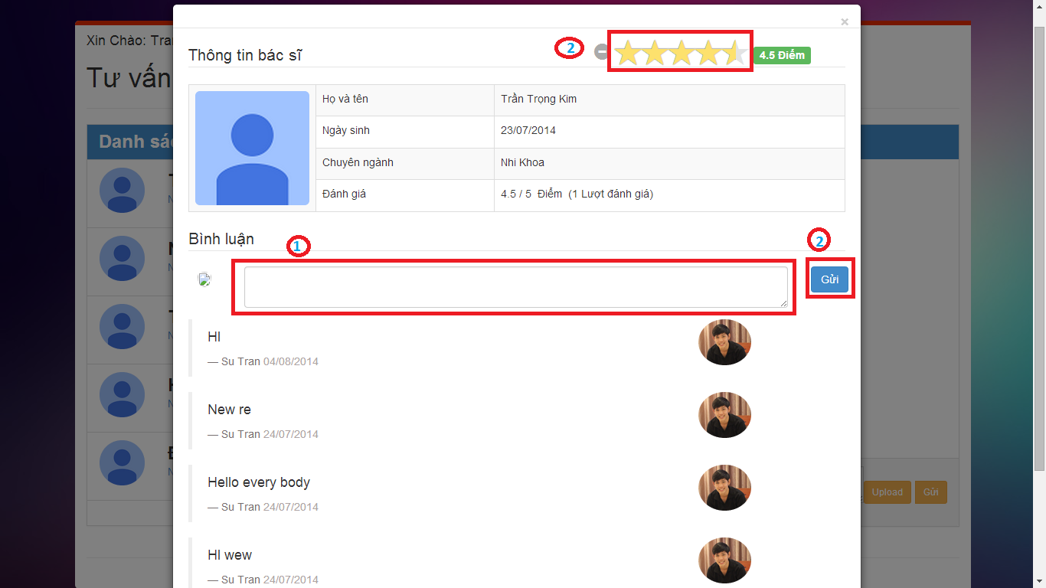

Figure 20 View Doctor Details Page

|  |  |
| --- | --- |
| **Step** | **Description** |
| 1 | Fill the text-area. |
| 2 | Click on “Gửi” button to send the comment.  Click on “Đánh giá” to rate for the doctor. |

Table 9 View Doctor Details Step

### Doctor - Manage Patient

#### Create New Patient

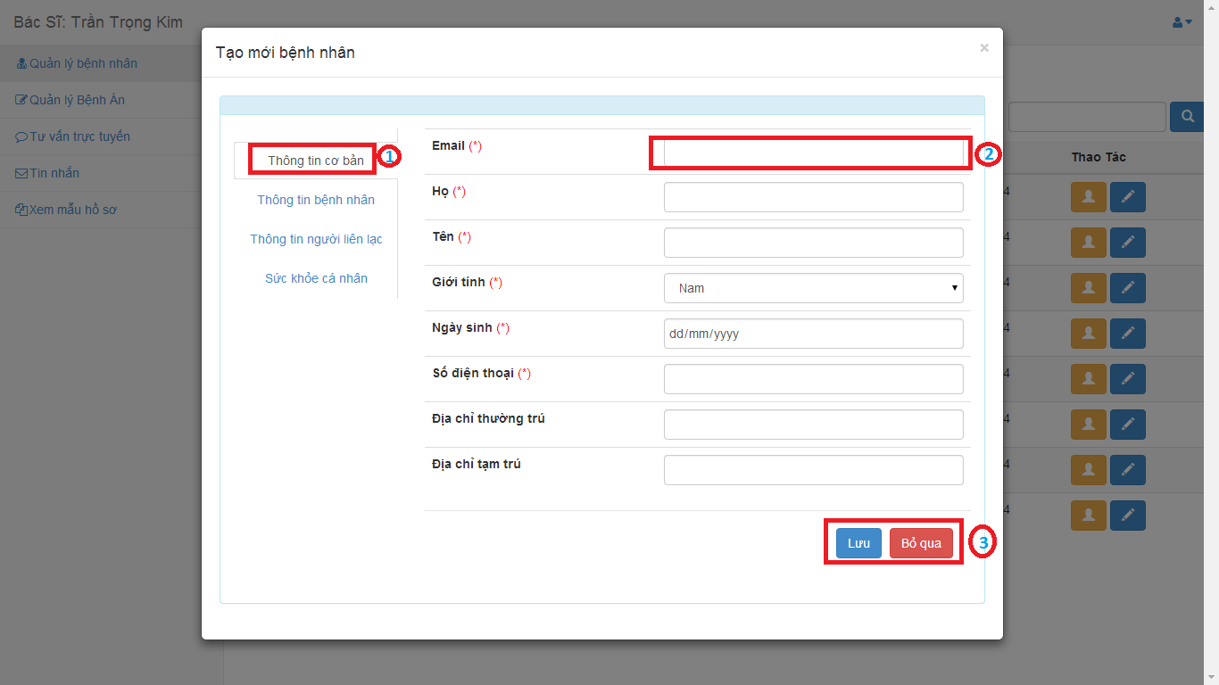

Figure 21 Create New Patient Page

|  |  |
| --- | --- |
| **Step** | **Description** |
| 1 | Choose the tab. |
| 2 | Input the value. |
| 3 | Click on “Lưu” button to create new patient.  Click on “Bỏ qua” button to cancel. |

Table 10 Create New Patient Step

#### View Patient Details

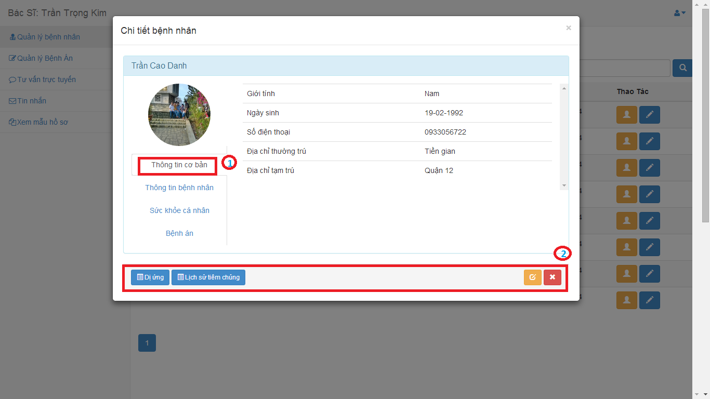

Figure 22 View Patient Details Page

|  |  |
| --- | --- |
| **Step** | **Description** |
| 1 | Choose the tab to view |
| 2 | Click on “Dị ứng” button to view allergy history.  Click on “Lịch sử tiêm chủng” button to view vaccination history.  Click on “Cập nhật” button to edit patient details.  Click on “Bỏ qua” button to close. |

Table 11 View Patient Details Step

#### Edit Patient Details

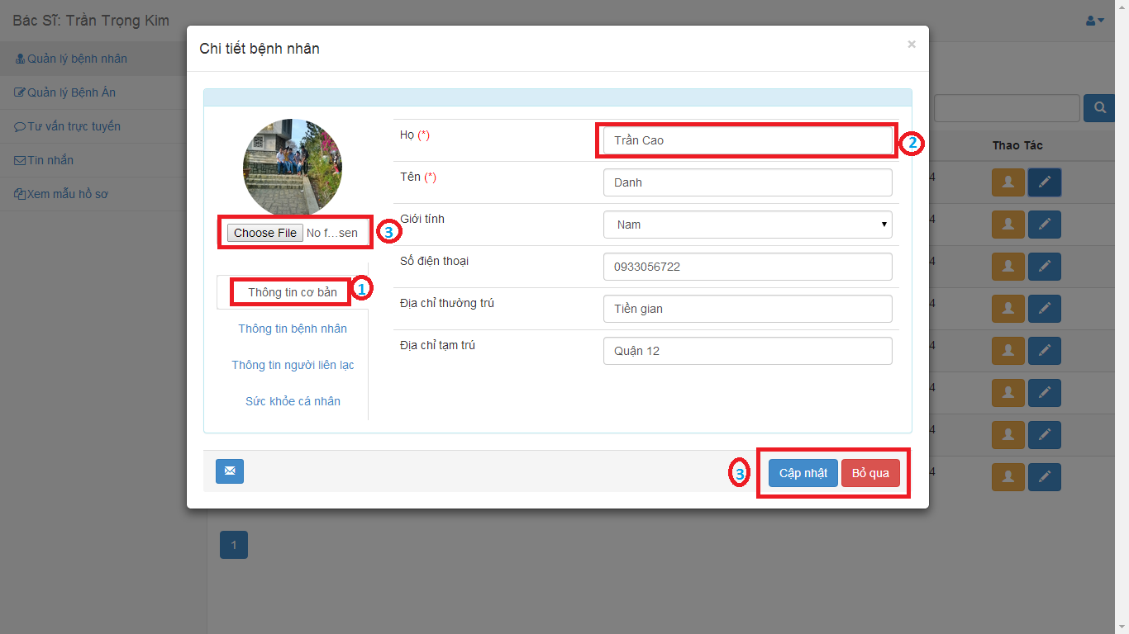

Figure 23 Edit Patient Details Page

|  |  |
| --- | --- |
| **Step** | **Description** |
| 1 | Choose the tab to view |
| 2 | Input the value |
| 3 | Click on “Choose file” button to upload new profile image.  Click on “Cập nhật” button to save.  Click on “Bỏ qua” button to cancel. |

Table 12 Edit Patient Details Step

### Doctor – Consult Online

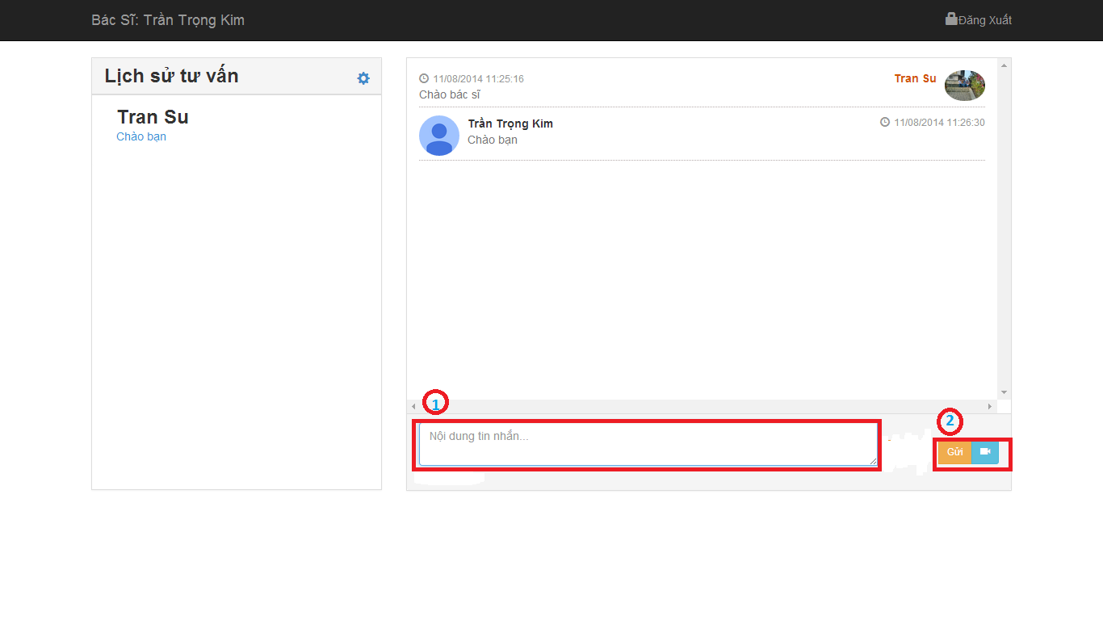

Figure 24 Consulting Online Page

|  |  |
| --- | --- |
| **Step** | **Description** |
| 1 | Fill the text-box. |
| 2 | Click on “Gửi” button to send message.  Click on “Webcam” button to request watching patient’s webcam. |

Table 13 Consult Online Step

### Doctor – Message

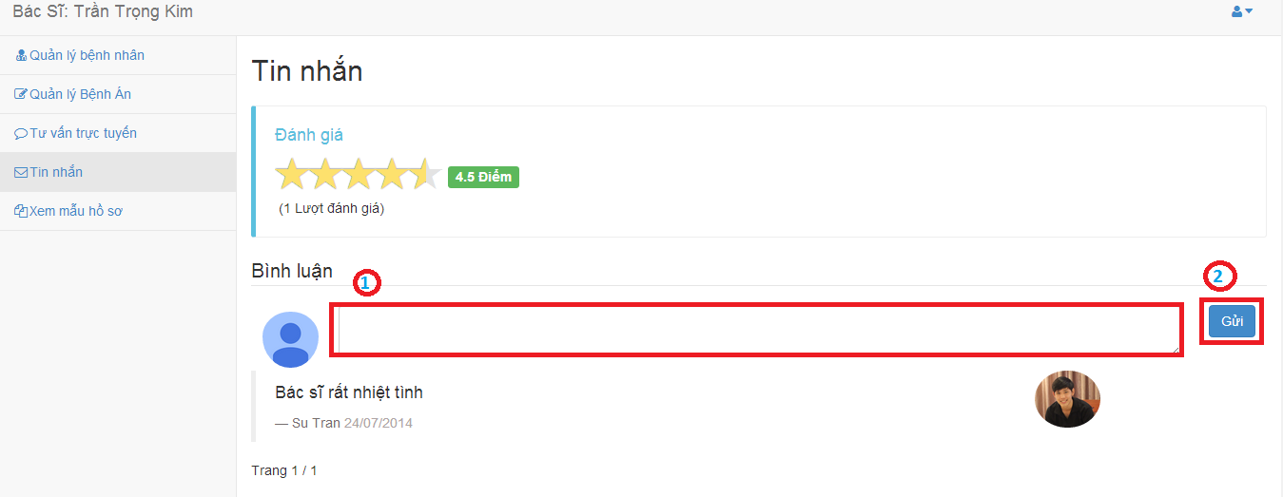

Figure 25 Message Page

|  |  |
| --- | --- |
| **Step** | **Description** |
| 1 | Fill the text-box. |
| 2 | Click on “Gửi” button to send comment. |

Table 14 Comment Step

### Admin – Manage Hospital Information

#### View/Edit hospital information

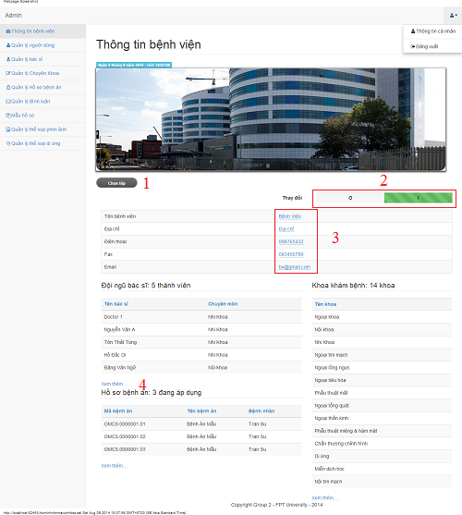

Figure 26 View/Edit Hospital Information Page

|  |  |
| --- | --- |
| **Step** | **Description** |
| 1 | Select file to change hospital’s logo |
| 2 | Click on “I” to edit hospital information or click on “O” to view hospital information |
| 3 | Fill hospital information to edit |
| 4 | Click on “Xem thêm….” to forward to other page |

Table 15 View/Edit Hospital Information Step

### Admin – Manage Users

#### View user list

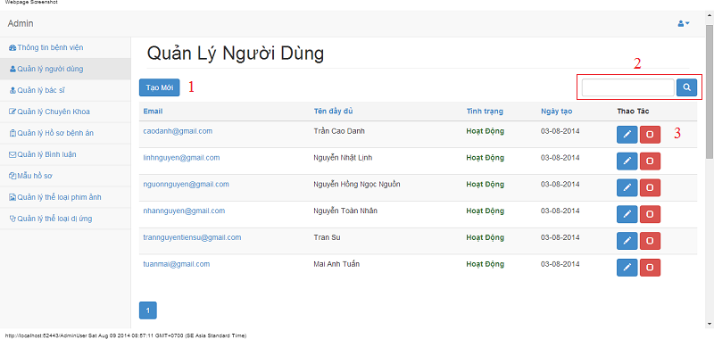

Figure 27 View Users Page

|  |  |
| --- | --- |
| **Step** | **Description** |
| 1 | Fill user’s name/email and click search button to find user |
| 2 | Click “Tạo mới” button to create a new user |
| 3 | Click edit button to edit user’s details  Click check button to lock or unlock user |

Table 16 View Users Step

#### Create user

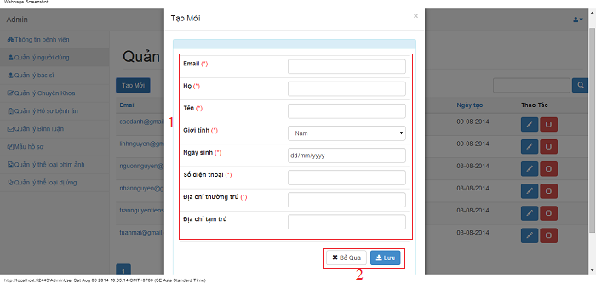

Figure 28 Create User Page

|  |  |
| --- | --- |
| **Step** | **Description** |
| 1 | Fill all user detail |
| 2 | Click on “Lưu” button to save user  Click on “Bỏ qua” dismiss modal |

Table 17 Create User Step

#### Edit user

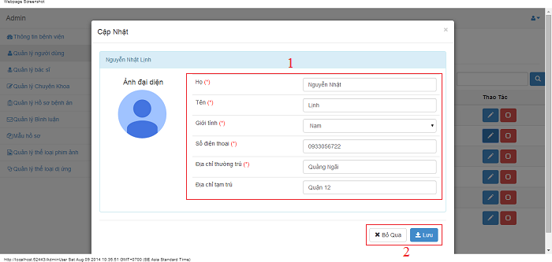

Figure 29 Edit User Page

|  |  |
| --- | --- |
| **Step** | **Description** |
| 1 | Fill all user detail to edit |
| 2 | Click on “Lưu” button to save user  Click on “Bỏ qua” dismiss modal |

Table 18 Edit User Step

### Admin – Manage Doctors

#### View doctor list

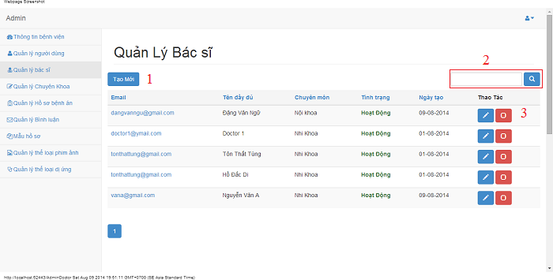

Figure 30 View Doctors Page

|  |  |
| --- | --- |
| **Step** | **Description** |
| 1 | Fill doctor’s name/email and click on search button to find user |
| 2 | Click on “Tạo mới” button to create a new doctor |
| 3 | Click on edit button to edit doctor’s details  Click on check button to lock or unlock doctor |

Table 19 View Doctors Step

#### Create doctor

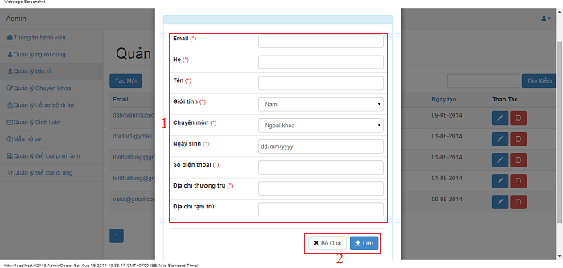

Figure 31 Create Doctor Page

|  |  |
| --- | --- |
| **Step** | **Description** |
| 1 | Fill all doctor detail |
| 2 | Click on “Lưu” button to save doctor  Click on “Bỏ qua” dismiss modal |

Table 20 Create Doctor Step

#### Edit doctor

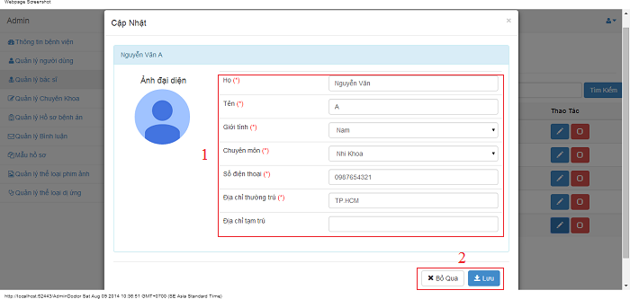

Figure 32 Edit Doctor Page

|  |  |
| --- | --- |
| **Step** | **Description** |
| 1 | Fill all doctor detail to edit |
| 2 | Click on “Lưu” button to save doctor  Click on “Bỏ qua” dismiss modal |

Table 21 Edit Doctor Step

### Admin – Manage Medical Profiles

#### View medical profile list

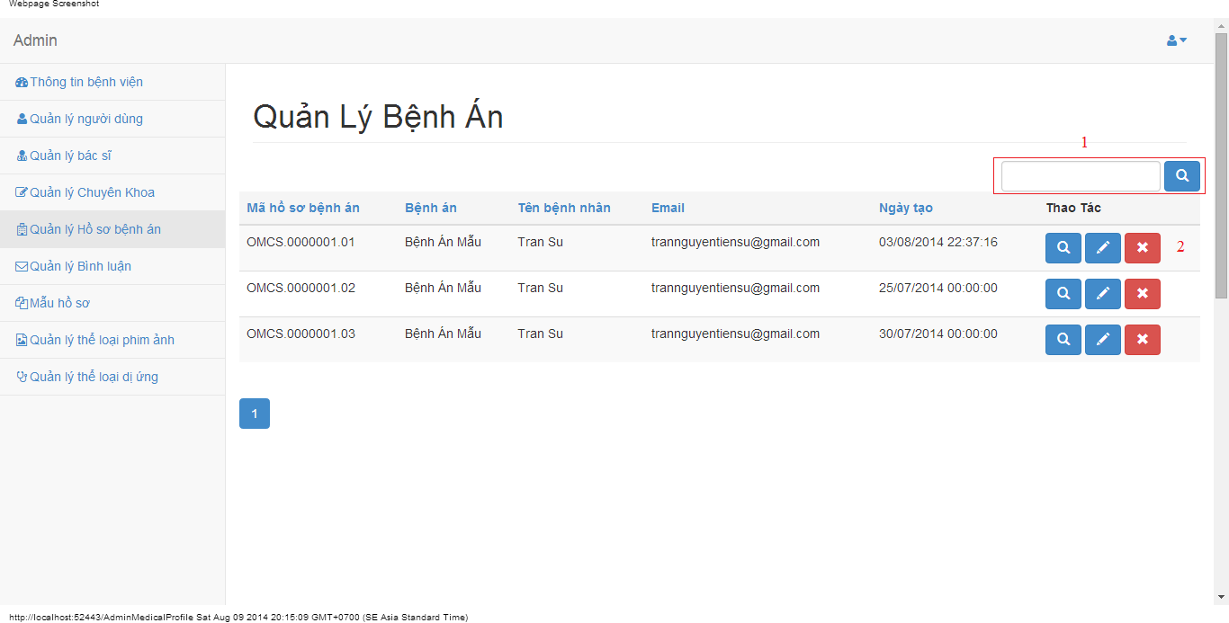

Figure 33 View Medical Profiles Page

|  |  |
| --- | --- |
| **Step** | **Description** |
| 1 | Fill medial profile name/key/patient’s name and click on search button to find medical profile |
| 2 | Click on view button to view medical profile’s details  Click on edit button to edit medical profile’s details  Click on delete button to delete medical profile’s details |

Table 22 View Medical Profiles Step

#### View details a medical profile

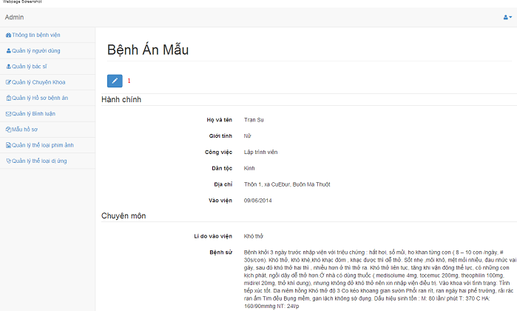

Figure 34 Details Medical Profile Page

|  |  |
| --- | --- |
| **Step** | **Description** |
| 1 | Click on edit button to forward to edit medical profile |

Table 23 Details Medical Profile Step

#### Update medical profile

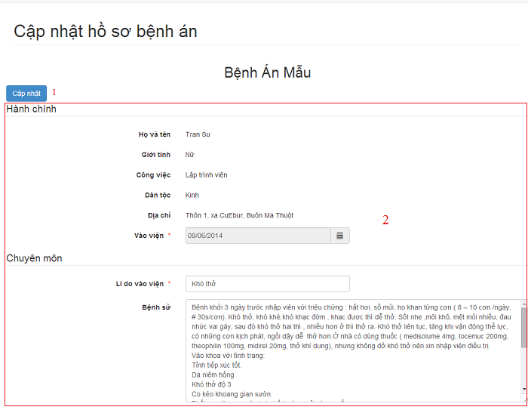

Figure 35 Update Medical Profile Page

|  |  |
| --- | --- |
| **Step** | **Description** |
| 1 | Click on “Cập nhật” button to save doctor |
| 2 | Fill all medical profile detail to edit |

Table 24 Update Medical Profile Step

### Admin – Manage Specialty Fields

#### View specialty fields

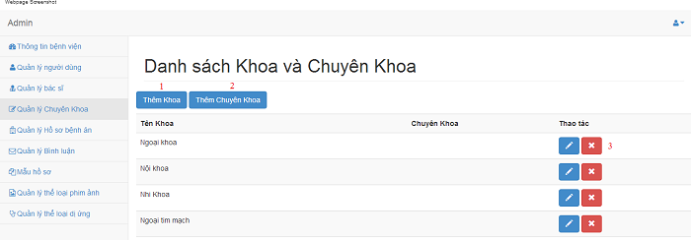

Figure 36 View Specialty Fields Page

|  |  |
| --- | --- |
| **Step** | **Description** |
| 1 | Click on “Thêm Khoa” button to create a parent specialty |
| 2 | Click on “Thêm Chuyên Khoa” button to create a specialty |
| 3 | Click on edit button to edit specialty’s details  Click on remove button to delete a specialty field |

Table 25 View Specialty Fields Step

#### Create parent specialty field

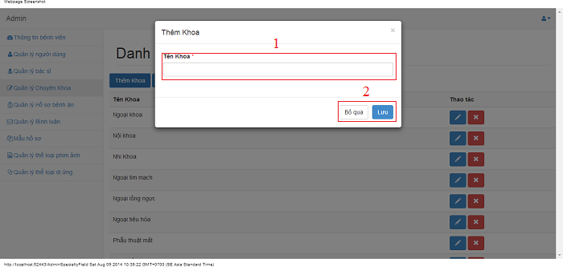

Figure 37 Create Parent Specialty Field Page

|  |  |
| --- | --- |
| **Step** | **Description** |
| 1 | Fill all parent specialty detail |
| 2 | Click on “Lưu” button to save parent specialty  Click on “Bỏ qua” dismiss modal |

Table 26 Create Parent Specialty Field Step

#### Create specialty field

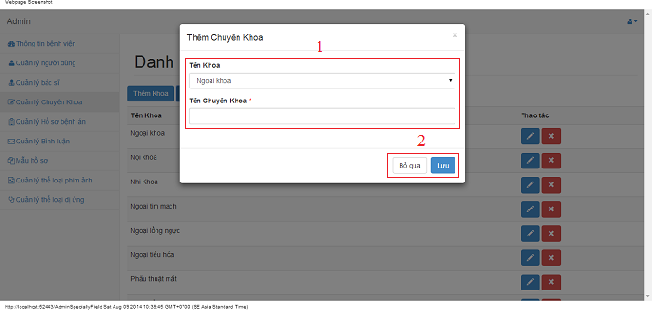

Figure 38 Create Specialty Field Page

|  |  |
| --- | --- |
| **Step** | **Description** |
| 1 | Fill all specialty detail |
| 2 | Click on “Lưu” button to save specialty  Click on “Bỏ qua” dismiss modal |

Table 27 Create Specialty Field Step

#### Edit parent specialty field

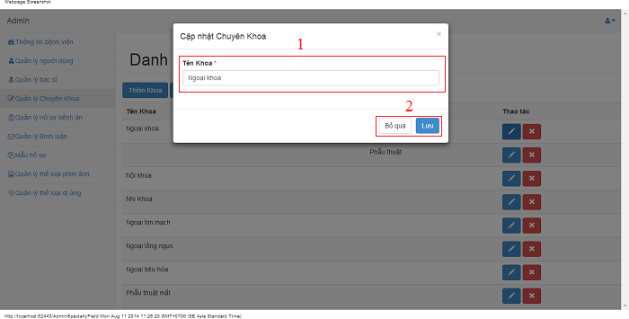

Figure 39 Edit Parent Specialty Field Page

|  |  |
| --- | --- |
| **Step** | **Description** |
| 1 | Fill all parent specialty detail to edit |
| 2 | Click on “Lưu” button to save parent specialty  Click on “Bỏ qua” dismiss modal |

Table 28 Edit Parent Specialty Field Step

#### Edit specialty field

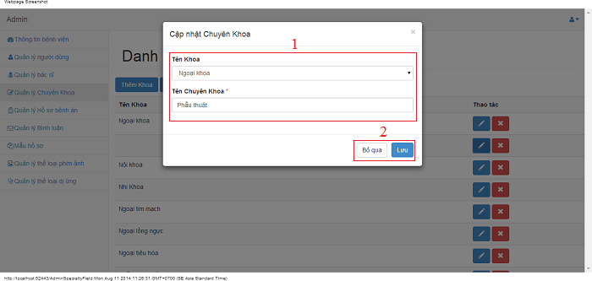

Figure 40 Edit Specialty Field Page

|  |  |
| --- | --- |
| **Step** | **Description** |
| 1 | Fill all specialty detail to edit |
| 2 | Click on “Lưu” button to save specialty  Click on “Bỏ qua” dismiss modal |

Table 29 Edit Specialty Field Step

### Admin – Manage Medical Profile Templates

#### View medical profile template list

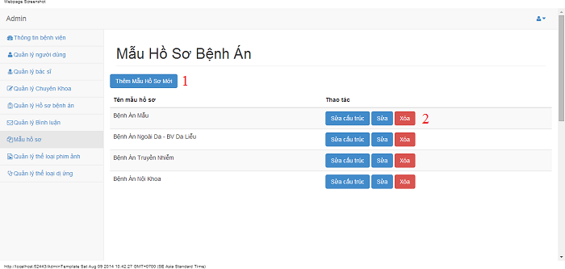

Figure 41 View Medical Profile Templates Page

|  |  |
| --- | --- |
| **Step** | **Description** |
| 1 | Click on “Thêm Mẫu Hồ Sơ Mới” button to create a medical profile template |
| 2 | Click on “Sửa cấu trúc” button to edit medical profile template  Click on “Sửa” button to edit medical profile template name  Click on “Xóa” button to delete a medical profile template |

Table 30 View Medical Profile Templates Step

#### Create medical profile template

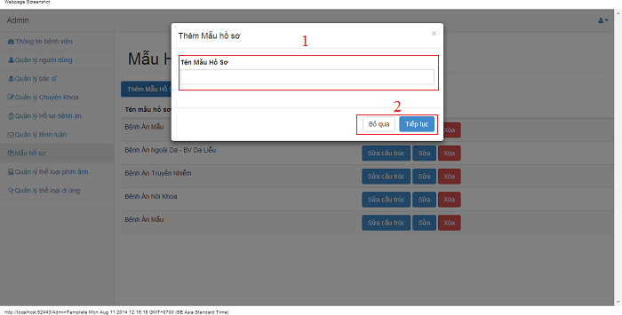

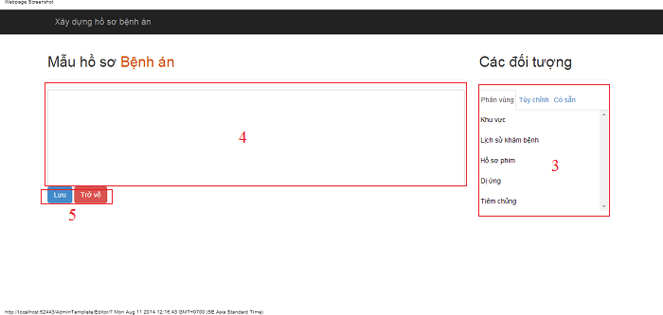

Figure 42 Create Medical Profile Template Page

|  |  |
| --- | --- |
| **Step** | **Description** |
| 1 | Fill medical profile template name |
| 2 | Click on “Tiếp tục” button to create medical profile template  Click on “Bỏ qua” button to dismiss modal |
| 3 | Step 2 click on “Tiếp tục” button  Drag value on 3 tabs: “Phân vùng”, “Tùy chỉnh” and “Có sẵn” in step 4 |
| 4 | Admin drag value on tab to this |
| 5 | Click on “Lưu” button to save medical profile template  Click on “Trở về” button to redirect previous page. |

Table 31 Create Medical Profile Template Step

#### Update medical profile template name

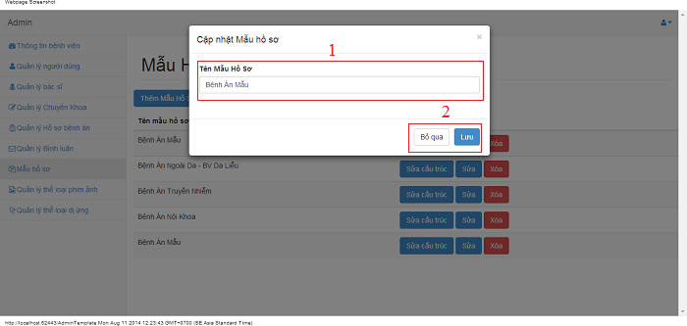

Figure 43 Update Medical Profile Template Name Page

|  |  |
| --- | --- |
| **Step** | **Description** |
| 1 | Fill medical profile template name |
| 2 | Click on “Tiếp tục” button to edit medical profile template name  Click on “Bỏ qua” button to dismiss modal |

Table 32 Update Medical Profile Template Name Step

### Update medical profile template

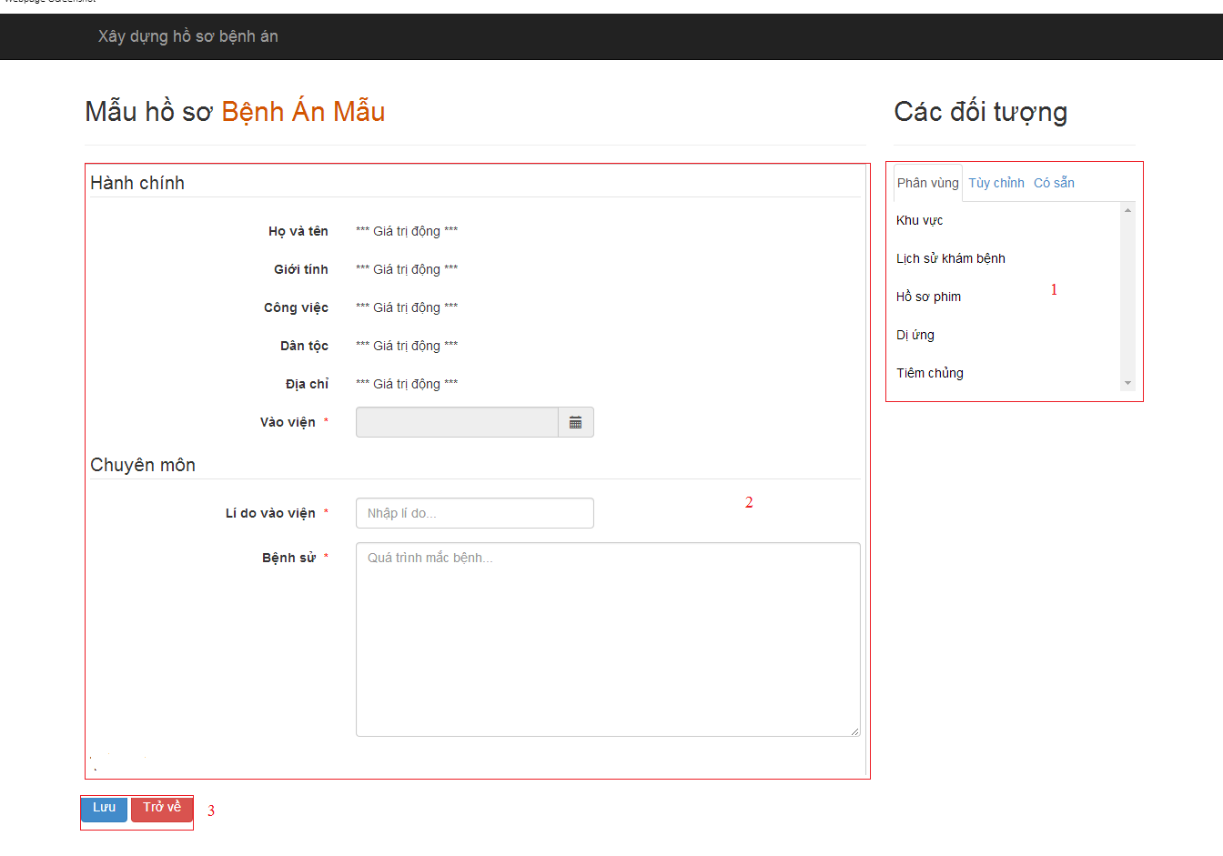

Figure 44 Update Medical Profile Template Page

|  |  |
| --- | --- |
| **Step** | **Description** |
| 1 | Drag value on 3 tabs: “Phân vùng”, “Tùy chỉnh” and “Có sẵn” in step 2 |
| 2 | Admin drag in or out value on tab to this |
| 3 | Click on “Lưu” button to save medical profile template  Click on “Trở về” button to redirect previous page. |

Table 33 Update Medical Profile Template Step

### Admin – Manage Personal Information

#### View/Edit personal information

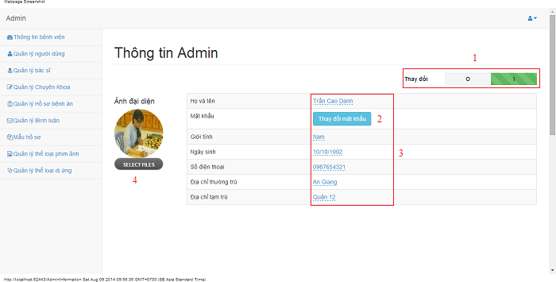

Figure 45 View/Edit Admin Information Page

|  |  |
| --- | --- |
| **Step** | **Description** |
| 1 | Click on “I” to edit personal information or click on “O” to view personal information |
| 2 | Click on “Thay đổi mật khẩu” button to edit password |
| 3 | Fill personal information to edit |
| 4 | Select file to change profile picture |

Table 34 View/Edit Admin Information Step